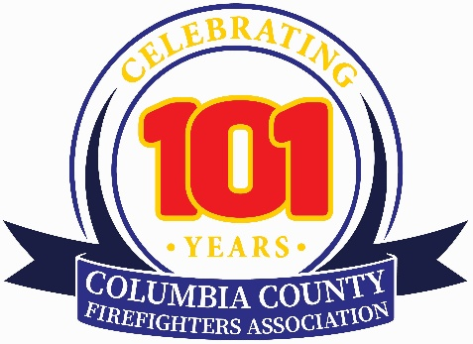
Columbia County Volunteer Fireﬁghter's Association
CCVFA2026@gmail.com

January 2025

[Sponsor Contact Name]
[Sponsor Title]
[Company Name]
[Company Address]

Subject: An Invitation to Partner with the Columbia County Volunteer Fireﬁghters’ Association

Dear [Contact Name],

The Columbia County Volunteer Fireﬁghter's Association (CCVFA) is an organization dedicated to supporting the volunteer ﬁre departments that protect the lives and property of our businesses and residents. We are reaching out to local business leaders like you to request your support as a Corporate Sponsor for the 2025–2026 year. Your generous contribution helps us provide critical support and resources to the 31 volunteer ﬁre departments across Columbia County.

For over a century, our volunteer ﬁreﬁghters have been at the heart of community safety, responding to emergencies with courage and dedication. As many of our departments have now celebrated their 100th anniversaries, we are focused on strengthening our capabilities and ensuring our volunteers have the tools they need to stay safe while serving others.

Your corporate sponsorship will directly fund vital initiatives, including:
- Fireﬁghter Recruitment and Retention: Supporting our efforts to recruit new volunteers and to retain those we already have.
- Advanced Training Programs: Ensuring our members are equipped with the latest skills and certiﬁcations.
- Community Safety and Outreach: Funding educational programs for residents on fire prevention and emergency preparedness.

In recognition of your commitment to our mission, we have developed several sponsorship levels, each offering opportunities that provide valuable exposure for your business.

- Branding and Promotion: Your company logo, name, and message in an advertisement displayed in our Yearbook, which is distributed to ﬁre company stations and members, as well as family, friends, and associates.
- Recognition: A banner with your company’s name and logo. Public acknowledgment of your support at CCVFA functions, including meetings and at the upcoming 2026 Convention and Dress Parade, which will be held in the Village of Chatham and at the Columbia County Fairgrounds.
- Community Goodwill: The opportunity to demonstrate your company's dedication to the safety and well-being of the Columbia County community.
Here are the Corporate Sponsorships available:

- $2,000 - Platinum Sponsor – 3’ by 3’ Banner and a Color Ad on Back Page of 2026 Yearbook **Only ONE Available – First Come, First Served**
- $1,500 - Gold Sponsor: 3’ by 3’ Banner and a Color Ad on Inside Cover of 2026 Yearbook **Only TWO Available – First Come, First Served**
- $1,000 - Silver Sponsor: 3’ by 3’ Banner – Full Page Color Ad Inside the 2026 Yearbook
- $500 - Bronze Sponsor: 2’ by 2’ Banner - Half Page Color Ad Inside the 2026 Yearbook
We are conﬁdent that a partnership with the CCVFA is a mutually beneﬁcial investment that aligns your company with a cause deeply valued by the ﬁreﬁghter and the residents of Columbia County. This opportunity to make a meaningful impact in our Association is appreciated. We will follow up to answer any questions, or you may email us at CCVFA2026@gmail.com

Sincerely,
[Your Signature]
[Your Name]

